Algorithm Development

Speech Corruption Enhancement

Team:

Carpe Noctem

Team Leaders:

Christopher Rappa & Carlos Lazo

Team Members:

Carlos Lazo, Christopher Rappa, Jake Tisdale, Michael Sangillo

Course: TDC1 – Algorithm Development

Instructor: Michael Richman

Group Hours: 30 hours

Date Submitted: 11/10/08

Table of Contents

Introduction 3
Performance Criteria 3
Part I 4
Characterization of Corruption 4
Algorithm 5
Algorithm Analysis 6
Part 2 6
Characterization of Corruption Levels 1, 2, & 3 7
Algorithm 9
Specification of Corruption Levels 1, 2, & 3 10
Analysis of Corruption Levels 1, 2, & 3 10
Results & Conclusion 11
Part 1 11
Part 2 11

List of Figures

Figure 1 – Spectrogram of p1s1 (Corrupted) 4
Figure 2 – Spectrogram of p1s2 (Corrupted) 4
Figure 3 – Filter Frequency Response 5
Figure 4 – Spectrogram of p1s1 (Clean) 6
Figure 5 – Spectrogram of p1s2 (Clean) 6
Figure 6 – Signal Height vs. # of Bins (1) 7
Figure 7 – Signal Height vs. Bin Width (1) 7
Figure 8 – Signal Height vs. # of Bins (2) 8
Figure 9 – Signal Height vs. Bin Width (2) 8
Figure 10 – Signal Height vs. # of Bins (3) 8
Figure 11 – Signal Height vs. Bin Width (3) 8
Figure 12 – Algorithm Encoding Scheme (Example) 9

List of Tables

Table 1 – Metric Results for ‘Rich’ file: 11

Introduction

Algorithm Development is an integral process in the defense engineering industry. As a primary defense contractor and systems integrator, it is important for BAE Systems to effectively derive realizable algorithmic solutions to real world problems. Our TDC group, Team Carpe Noctem, has been asked to investigate a few scenarios in the realm of speech enhancement. We are asked to analyze corrupted speech signals in an attempt to recover the original, uncorrupted signals through MATLAB. In going through the algorithm development process, our group successfully derives and justifies our signal reconstruction solutions based on audible and quantitative metric comparisons.

The problem is split into two sections. In the first part, we are given two corrupted speech signals, each having been corrupted by a similar method. The goal is to reduce or remove the effects of the corruption. The second part of the investigation allows us to characterize the effects of a black box function which effectively simulates a transmission channel. The channel has three different levels of corruption. Through pre and post processing, we must find a way to counteract the corruption seen in speech transmission.

Performance Criteria

In reading through all specifications and problem constraints, our team felt it a good idea to develop criteria as soon as the corruption was characterized. Having a clear vision in mind from the beginning of each part helped us focus and gauge our progress through the algorithm development cycle. Our criteria for what we considered to be conclusive results are as follows:

Part 1
The output signal from our algorithm must sound noticeably better than the corrupted input signal. A panel of independent judges must unanimously agree that the signal has been improved for this criterion to be met.

Part 2
In order to determine the performance of the algorithm used, a metric was created to quantifiably validate the results. The metric is the normalized standard deviation of the difference between the input and output speech signals. This metric value effectively reports the signal reconstruction accuracy. This metric was evaluated by a panel of independent judges and found to accurately represent the speech reconstruction quality. We did examine industry standard speech metrics like Perceptual Evaluation of Speech Quality (PESQ) and Speech Quality Index (SQI), but found them to be misrepresentative of our judge’s opinions. We establish our part two criteria as follows:

- The encoded speech signal shall be less than or equal to two times the length of the original input speech signal. This was not explicitly set. We decided that a length of two was a conservative restriction that gave us algorithmic freedom without pressing the customer’s guidelines.
- The decoded output speech signal shall obtain a metric value of less than one; our independent judges found this value to be threshold at which discernable speech became evident. Our judges also determined that a metric value less than or equal to one constitutes adequate reconstruction.

To find the fundamental base or the threshold of sensibly audible speech, an independent team of 3 people were polled to test different levels of corruption. Based on the independent tests, the statistical observations state that any normalized standard deviation above a value of one is considered to be inaudible. This means that the algorithm settings or method used for that specific test would be considered invalid.

Part I

For part 1, we were given two corrupted speech signals (p1s1 and p1s2). Our goal was to evaluate the corruption and develop a method to reduce or remove this distortion from the signal. Our process can be seen below:

- Characterize the corruption in both signals.
- Devise criteria for an acceptable solution.
- Create an algorithm that will reduce or eliminate the corruption.
- Evaluate the clean signal and determine effectiveness.
- Revise previous steps to optimize the solution.

Characterization of Corruption

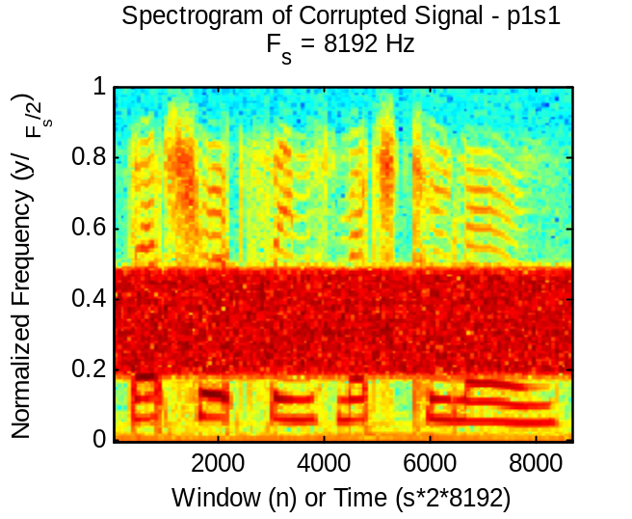 | 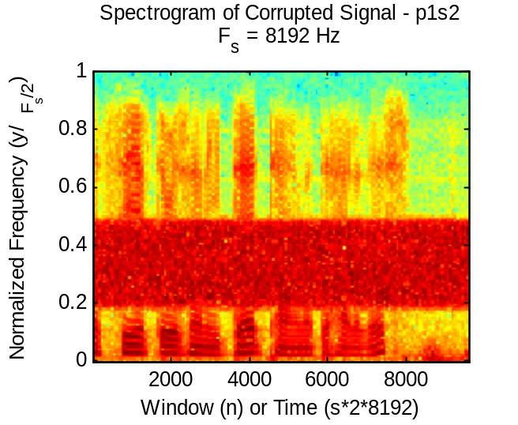 | 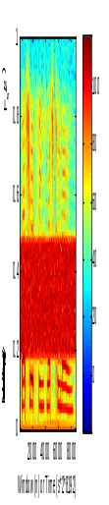  Fourier Amplitude
We used the clean signals to establish an initial baseline for our analysis. We listened to the original signals and the corrupted signals, getting a basic understanding on the corruption. Between the clean and corrupted signals, we noticed that the amplitude and pitch of the speech remained the same; there was no echo, no obvious super imposed audio, and no timing change. However, some noise was present. This noise was common to both corrupted signals. Since the human auditory system can not quantify the noise of this corruption, we used MATLAB’s specgram tool to plot the spectrogram of the two signals. The spectrograms allowed us to examine the normalized time-sampled frequency content of both signals. This gave us a clearer picture of the corruption. shows the spectrogram of p1s1 while Error: Reference source not found shows p1s2.
Figure 1 – Spectrogram of p1s1 (Corrupted)
Figure 2 – Spectrogram of p1s2 (Corrupted)
Speech often follows a specific form in a spectrogram. This form is referred to as a “ladder form” because the frequency content looks like a ladder. We observed the location of the speech content by looking for these specific forms.

We noticed that there were very clear ladder forms in similar time samples. However, these forms seemed to be washed out within a certain frequency band filled with noise. This noise was common to both signals and of equal levels, max of one hundred and twenty. Also, the noise was time-invariant. Since the audio has been saturated with noise in this band, we decided that in order to improve upon the signal quality, we needed to remove this noise. We defined removal to be any content that has equal amplitude with the background noise of the signal. To keep the complexity of the algorithm to a minimum, we decided to abandon any signal reconstruction in the noise band. The spectrogram also allowed us to see the relative amplitude of the background noise. In both signals, the background noise has amplitude of around thirty.

Algorithm

By definition, removal of time-invariant frequency content in a certain band is implemented by using a band-stop filter. There are many ways to implement this style of filter. First, we established a set of requirements for our filter. We wanted to minimize our signal distortion and completely remove the corruption. This means the filter attenuation in the stop-band must be sufficient enough to reduce the noise to background noise. Also, the filter should have less than 0.5 dB of attenuation or ripple in the pass-band. Finally, the filter should have a linear phase response to minimize signal distortion. These are all common requirements in filter design.

Since this is a batch process, we did not need to place any restriction on the filter order. With this restriction lifted, we chose to use a finite impulse response (FIR) filter. These filters offer the sharpest cutoff and the least ripple, but are of high order. While there are many filters available, the best filter to use for this application is the Equiripple FIR filter. This type of filter puts a very high weight on reducing ripple in the pass-band. As a result, it maintains a consistent ripple in the stop-band. It also has linear phase response.
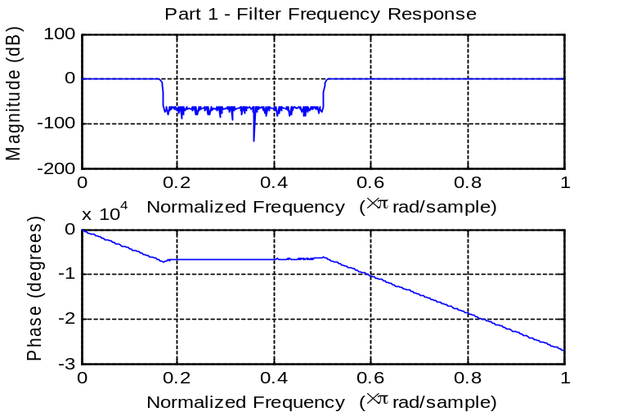
We used MATLAB’s Parks-McClellan filter design algorithm to design this filter. We inputted our filter requirements, but needed to choose appropriate cut-off frequencies, rise, and fall widths. We chose these points based on where we thought the minimum and maximum corrupted normalized frequencies laid. Though this might seem like an arbitrary decision, we also examined the fast Fourier transform (FFT) of the subtraction of our clean signal and the corrupted signal. This showed us the start and end frequencies of the noise. This was not the primary design motivator because we felt that doing this test would not be consistent with real-world situations. The rise and fall widths were chosen to be one twentieth of the sample frequency as is common choice in filter design. The frequency response of this filter can be seen in Error: Reference source not found.
Figure 3 – Filter Frequency Response

Algorithm Analysis

We applied this filter to both of our corrupted signals. Our team and a panel of unbiased reviewers all agreed that the noise had been eliminated and that the signal sounded better than the original corrupted version. The resulting signals met our final criteria for a “clean” signal. No further improvement needed to be made to our algorithm. Error: Reference source not found shows the spectrogram of the clean p1s1 and Error: Reference source not found shows the spectrogram of the clean p1s2.

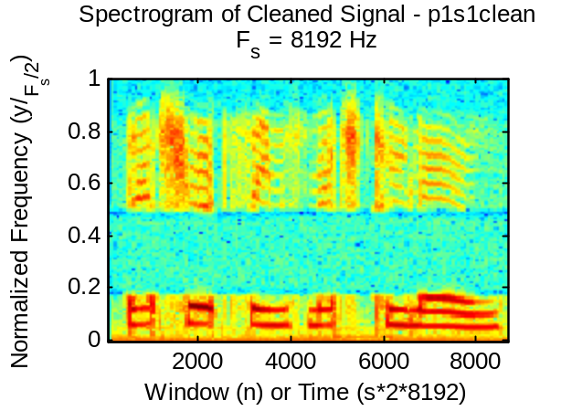  Figure 4 – Spectrogram of p1s1 (Clean) | 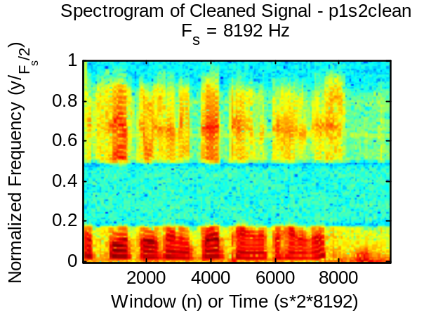  Figure 5 – Spectrogram of p1s2 (Clean) | Fourier Amplitude
Unfortunately, the filter eliminated frequency content that is present in speech signals. For future exploration, it might be worthwhile to examine speech signal reconstruction to fill-in the noise band. However, the results did meet our desired criteria. To avoid an infinite time-sink, our team and our judges agreed that this reconstruction was unnecessary.

Part 2

For part 2, we were given a black box function called ELDP which took two inputs: a speech signal and an integer from one to three. The output of this function would be a corrupted version of the original input signal; the level of corruption is dependant on the input integer value. Our problem-solving process can be seen below:

- Characterize the corruption at all three levels of the ELDP function.
- Devise criteria for an acceptable solution.
- Create an algorithm that will reduce or eliminate the corruption for all three levels.
- Evaluate the clean signal using audience and metrics to determine effectiveness.
- Revise previous steps to optimize the solution.

Characterization of Corruption Levels 1, 2, & 3

With a strategy in mind, our team began by characterizing the different levels of corruption. We started by sending monotonically increasing and periodic signals through the ELDP function to assess the outputted corruption. Through the use of histograms and plots, we noticed that the output signals showed the original signal being split into unique outputs, or bins. Through the use of MATLAB, it was determined that the number of bins in the output signal was dependant on the overall signal height of our speech file. We defined signal height as the maximum amplitude of the absolute value of our signal. Upon noticing this correlation, our group wanted to see if there was a way to fully predict the output of the signal based on the input and the level of corruption. This was done by plotting the signal height versus the number of bins, and by plotting the signal height versus the width of the bins.

For Level 1, the number of bins increased linearly as the signal’s amplitude increases until the signal amplitude hit 65,536. Anywhere above this number, we noticed that the number of bins stays constant at 129. This can be seen in Figure 6 – Signal Height vs. # of Bins. Next, the group looked at how the bin width changes as the input signal’s height increases. We noticed that bin width remained constant at 1024 until the signal amplitude hit 65,536, at which point the bin width increases linearly with the signal height. This can be seen in Figure 7 – Signal Height vs. Bin Width (1).

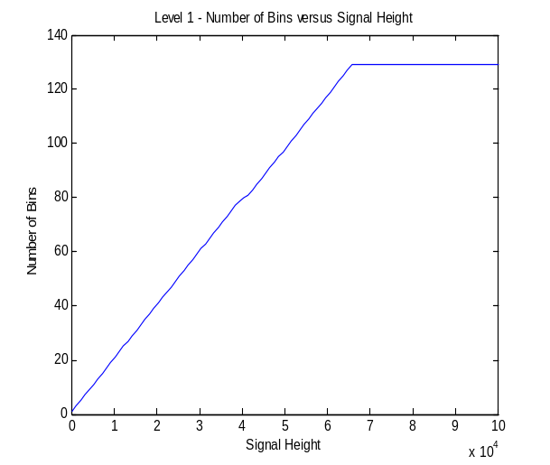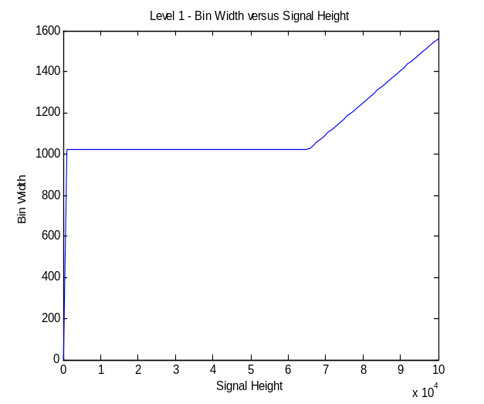
Figure 6 – Signal Height vs. # of Bins (1)
Figure 7 – Signal Height vs. Bin Width (1)
The group realized that if we always scaled the signal height to 65,536, then the number of output bins and the bin width would be known constants. This makes for an easier algorithm since the output of the transmission would exactly match the modified input.

Similar results where found for Level 2 – the number of bins increased as the signal height grew. The difference is that in Level 2, the number of bins became a constant value of 33 when the signal hit 65,536 in amplitude and beyond. This is can be seen in Figure 8 – Signal Height vs. # of Bins (2). The bin width for Level 2 started at a constant value of 4096. When the signal height hit 65,536 in amplitude, the bin width began increasing linearly with the signal height. This can be seen in Figure 9 – Signal Height vs. Bin Width (2).
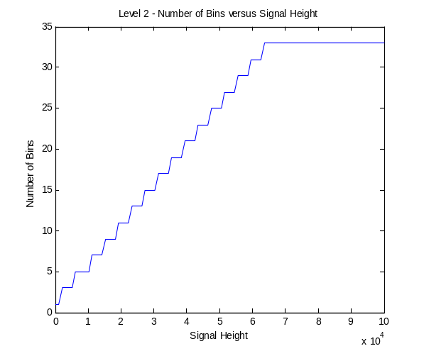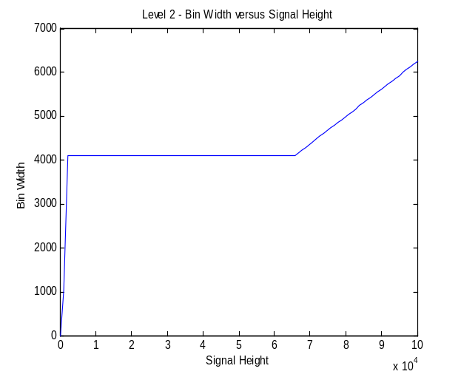
Figure 8 – Signal Height vs. # of Bins (2)
Figure 9 – Signal Height vs. Bin Width (2)
Level 3 was also found to operate in a similar manner. The number of bins becomes a constant value of 3 when the signal height hits 32,768 and beyond. This is seen in Figure 10 – Signal Height vs. # of Bins (3). Unlike Level 1 and 2, the bin width for Level 3 started at a constant and then makes a huge jump in width at a signal height of 32,768. Then, when the signal height hits 65,536 the bin width begins to increase linearly in a one-to-one ratio with the signal height. This means that if our signal height is greater than or equal to 65,536, our output will match our input. This can be seen in Figure 11 – Signal Height vs. Bin Width (3).

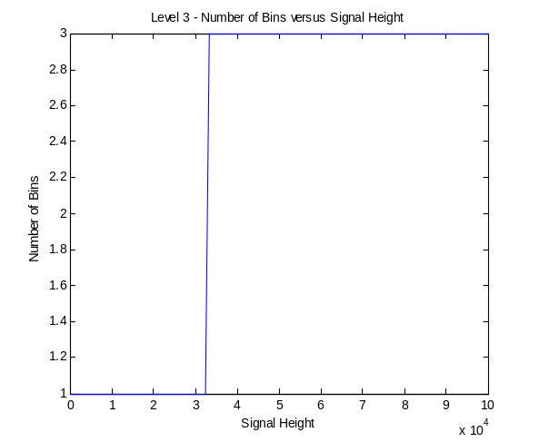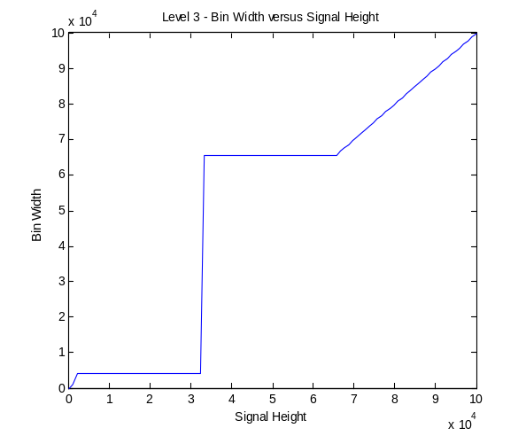
Figure 10 – Signal Height vs. # of Bins (3)
Figure 11 – Signal Height vs. Bin Width (3)

Algorithm

The goal of this algorithm is to encode a speech signal in such a way that the encoded data passed through the ELDP function would be unaffected. The ELDP black box is similar to an analog to digital converter, where the input data is quantized. Adaptive quantization is a process that varies the step size based on the changes in the input signal. The ELDP black box has N bins or quantization levels relative to the level of corruption. Since the output of the ELDP function is quantizing the data, we must pre-process our input so that this quantization would not produce any data loss in transmission.

Through research, we found that this was a common problem in the telecommunications industry; this is solved using a method called pulse-code modulation (PCM). PCM is the digital representation of an analog signal. This digital representation takes the analog values of the input and changes their number base so that they can be transmitted in a less precise form. Since we have an identified number of bins available in each step (n), we can translate our input into an n- based numerical system with multiple digits and produce a signal that would not be affected by transmission. However, this encoding process would increase the time of our transmission. Unlike Part 1, we chose to use PCM encoding because a filter is lossy and it would not be able to solve this problem effectively. The PCM approach is the best technique compared to all other options.

Let’s use Level 3 as an example. For Level 3, we know that the system can only output three symbols. Because of this, the encoding base for the PCM in this level of corruption is also three. Figure 12 – Algorithm Encoding Scheme illustrates how the encoding works for a three digit PCM. Every value in the input is encoded into a three digit sequence. For any encoding scheme, the number of digits could be increased or decreased to increase or decrease the precision respectively. With three digits in a base three system, the entire input range is divided into 3³ =27 bins. In this case, instead of having only three possible values, we have created an output with 27 unique values. This technique can be adapted to fit all levels of our system.

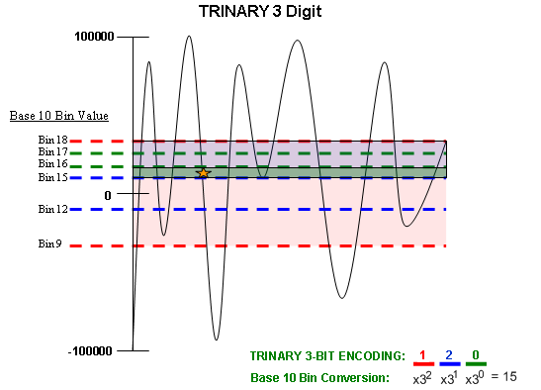
Figure 12 – Algorithm Encoding Scheme (Example)
Once the three digit code is sent through the ELDP black box, it can then be decoded. For our example, the decoding takes the base three, three digit code, and converts this number into a decimal value. This is done for every discrete sample. The final output speech signal is now a reconstruction of the original input signal. The accuracy of reconstruction depends on a few factors. The factors are the ELDP black box level corruption base constraint, the number of digits per discrete sample, and any compression used. Although using more digits increases resolution, it also increases the length of the encoded signal passed through the ELDP black box proportionately.

This is where compression techniques can be used prior to the encoding stage. We chose to implement a down-sampling compression technique. Down-sampling compression only transmits every n^{th} point. We are compressing by a factor of two, meaning that every other point would be transmitted. Once the signal is decoded and transmitted, it can then be decompressed by interpolation. Through this, we are now able to use four digits and stay within our length criterion. This increases the reconstruction resolution of that single sample point. The error due to compression loss is less than the error due to digit precision. When this compression technique is used to increase our precision, our speech quality is significantly improved.

Specification of Corruption Levels 1, 2, & 3

For Level 1, if we always scaled the signal height to 65,536, then the number of output bins would always be 129 with a width of 1024. For the algorithm, this means we could use 129 symbols with 2 bit encoding and get 16,641 bins of resolution. Our precision would be 1024/129².

For Level 2, if we always scaled the signal height to 65,536, then the number of output bins would be equal to 33 with a width of 4098. For the algorithm, this means we could use 33 symbols with 2 bit encoding and get 1,089 bins of resolution. Our precision would be 4096/33².

For Level 3, the group decided thief the signal height was scaled to somewhere above 65,526, then the number of bins would be constant. Also, the bin width would be a simple linear function based on the input signal’s height. For Level 3, if we used the maximum number of symbols, 3, and used the four bit encoding with a down-sampling factor of two, this gives us a resolution of 81 bins. Our precision would be A/81, where A being our scaled signal height.

Analysis of Corruption Levels 1, 2, & 3

The following data analysis is presented for the ‘rich.mat’ data provided:

The 2 digit, 129 symbol PCM encoding scheme for Level 1 gives excellent rating from our metric, 0.0008. The panel of independent judges heard little to no difference between the input and output signals.

The 2 digit, 33 symbol PCM encoding scheme for Level 2 gave us an acceptable metric rating of 0.0124. The panel of independent judges noticed a change between the output and input, but could still fully understand all the words.

We started our analysis of Level 3 by using a 2 digit, 3 symbol PCM encoding scheme. Our metric resulted in a value of 0.808, still audibly discernable based on our audience polling. Having implemented a down-sampling compression technique, we performed this same analysis using a 4 digit, 3 symbol PCM encoding scheme with ½ compression. Our metric yielded an improved value of 0.282, and our audience agreed that the sound quality of the output signal matched the input signal more closely.

The following table summarizes our error metric results for the ‘rich.mat’ file:
Table 1 – Metric Results for ‘rich’ file:
 | Default Output | 2-Digits No Compression | 4 Digits 1/2 Compression
Level 1 | 0.105 | 0.0008 | -
Level 2 | 0.410 | 0.0124 | -
Level 3 | - | 0.808 | 0.282

Results & Conclusion

Part 1

For both of the provided sound signals, we used a band stop filter. This filter successfully removed all corruption. No speech reconstruction was required.

Part 2

For Level 1 of corruption, we recommend the use of a two digit, 129 symbol PCM encoding scheme. This will result in adequate reconstruction based on our metric.

For Level 2 of corruption, we recommend the use of a two digit, 33 symbol PCM encoding scheme. This will result in adequate reconstruction based on our metric.

For Level 3 of corruption, we recommend the use of a four digit, 3 symbol PCM encoding scheme with a down-sampling compression factor of two. This will result in adequate reconstruction based on our metric.

As current BAE Systems engineers, this speech corruption investigation has helped our team understand the fundamentals of the Algorithm Development process from beginning to end. We feel that we have successfully characterized our functions and developed algorithms to effectively remove the speech corruption while meeting our performance criteria for both parts of the problem.

